Azure Data Factory
A data factory is a cloud data integration service used to compose data storage, movement, and processing services into automated data pipelines.

Connection and workflow of ADF
This example activity uses two Datasets as input source and output destination (sink), and these Datasets are connected using Linked services. Linked services are used to connect the actual storage location of data on both the source and destination ends. Integration Runtime binds this complete workflow, and to automate or perform this task with a single click, you will create a Pipeline.

Integration Runtime
Commonly known as IR, Integration Runtime is the heart of Azure Data Factory. IR provides the computer resources for data transfer activity and for dispatching data transfer activities in ADF. There are three types of Integration Runtime: Azure IR, Self-hosted, and Azure-SSIS.

Blob Storage
This cloud storage provided by Microsoft stores massive amounts of unstructured data, such as text or binary data. As you can see, the Customer.csv file with unstructured data of customer details is stored in blob storage.

Linked Service
Linked services connect data source and destination. In this example, the linked service connects to our data source i.e., blob storage. Data sources include Azure blob storage, Azure SQL Database, or on-premises SQL Server.

Dataset
Dataset connects to the data source and destination via linked services. Datasets are created based on the type of data source and destination you want to connect.

As you can see above, on the source side a blob storage type of dataset connects via a linked service to the actual location of data in blob storage. On the destination side, an SQL server type of dataset connects via a linked service, pointing to the exact table location in the database to store data.

Copy Activity
The activity in this pipeline is used to copy data between different data stores, and in this case, transform the data format as required in the destination store. Datasets are provided for this activity as input and output sources.

So, with this, you can understand ADF is the umbrella for all the components – such as Linked Service, Datasets, and Integration Runtime – fused in Pipeline Activity to produce transformed data for analytical tools such as Power BI and HDInsight for planning business outcomes.

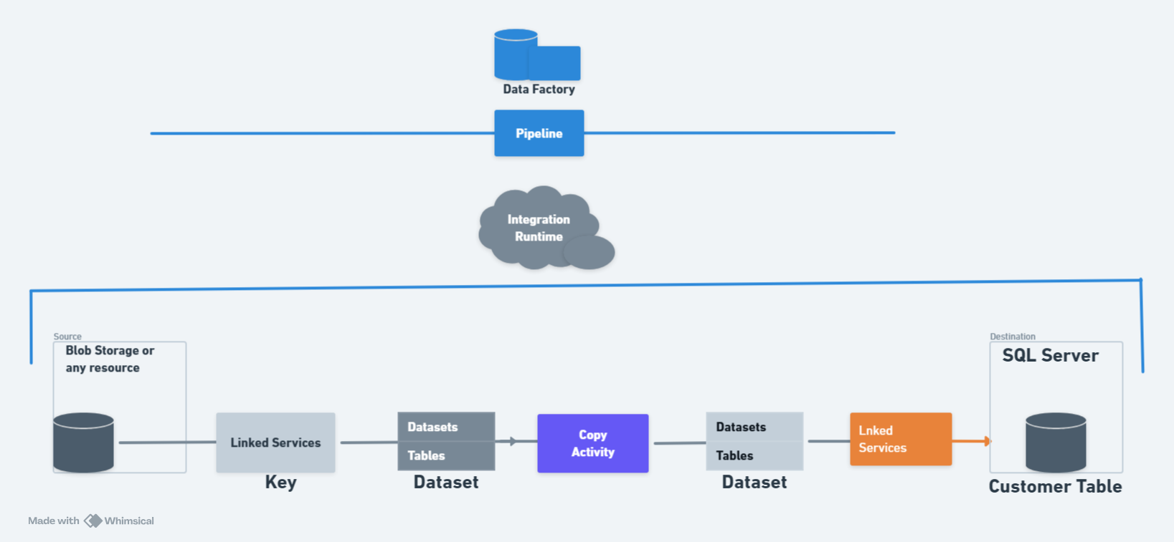

What is ETL?
As said above, ADF is an ETL and ELT tool for Data solutions. ETL stands for Extract, Transform,
and Load. ETL provides the method of moving the data from various sources into a data
warehouse. The image below illustrates the 3 stages of data flow in ADF i.e., E–extract,
Transform, and L – Load.
The ETL process collects unstructured data from the On-Premises SQL Database. Data is
Extracted into a cloud service storage platform for data transformation as per requirements. ADF
has the functions and activities that transform unstructured data into structured data for BI tools
and Analytics. With the help of ADF, the transformed data is then loaded into the data warehouse
On any cloud storage.
ETL is a process that uses cloud storage services for staging environments such as Blob, Data
Lake, S3 storage, and so on. Staging environments are like workspaces for actual data with
complete properties to test before it is stored.

Steps to Sink the Data from Source to Destination:
- Configure the source we require on Azure inside the ADF.
- Create linked services from connections to connect Source.
- Import the required data set or tables from the source.
- Create linked services from the connections to connect the destination.
- Import data to map the source.
- Copy data from the source to the destination. (To sink the dataset from the source to the destination)
  - From the Move and Transform:
    - We have the Copy Data-
      - Source, Sink, Mapping, User Properties
      - Mapping includes import schema and mappings
      - We can add a trigger for the pipeline or manually trigger the pipeline.

Steps to Replicate the Whole Database-

Create a Pipeline-
  - Name it according to your use.
  - Search for a lookup.
  - You can Name the process in general as GetAllTables.
  - Select the desired source for your process to get all the table values.
  - Use a dynamic approach to write queries instead of selecting the tables.
    - 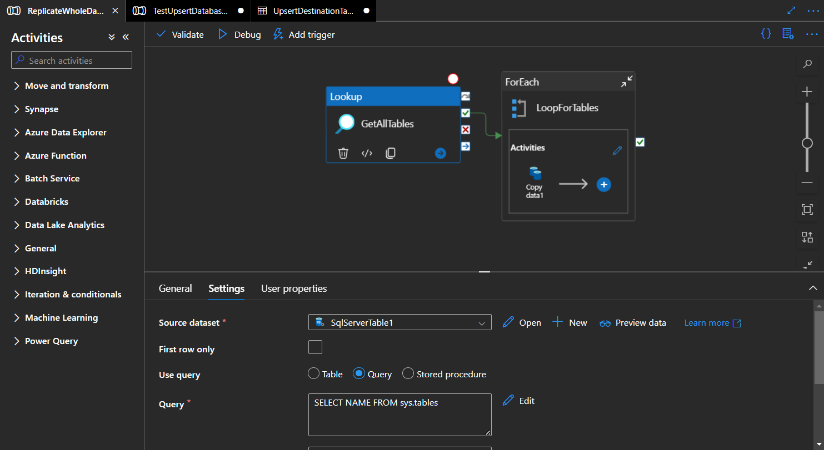
  - By debugging or clicking on preview you can view your query’s output.
    - 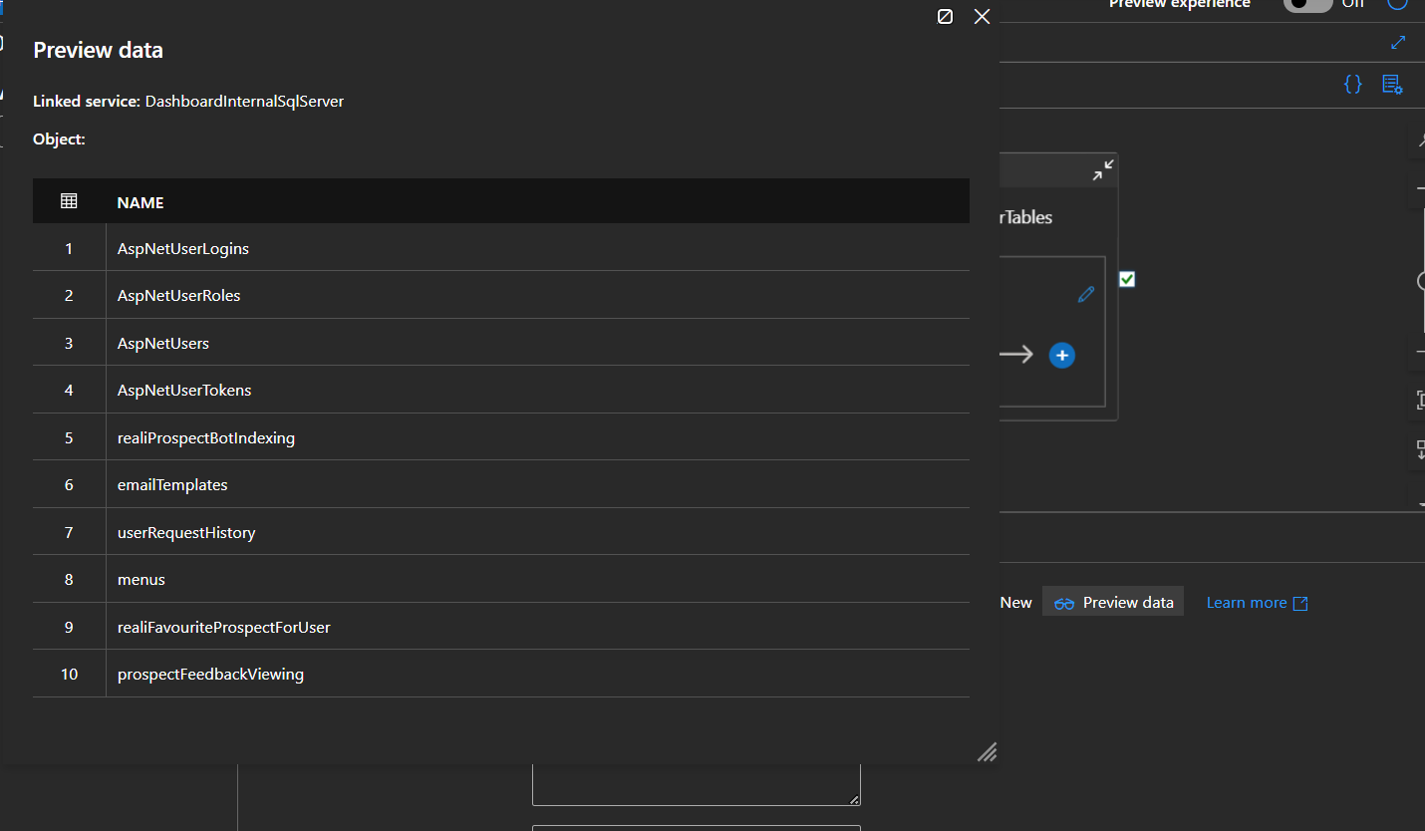
  - Select the For each and link it with the lookup after validating the lookup process.
  - Go to settings and select the dynamic approach at the bottom select your “lookup” and use “.value” to get the values of the tables from the lookup.
    - 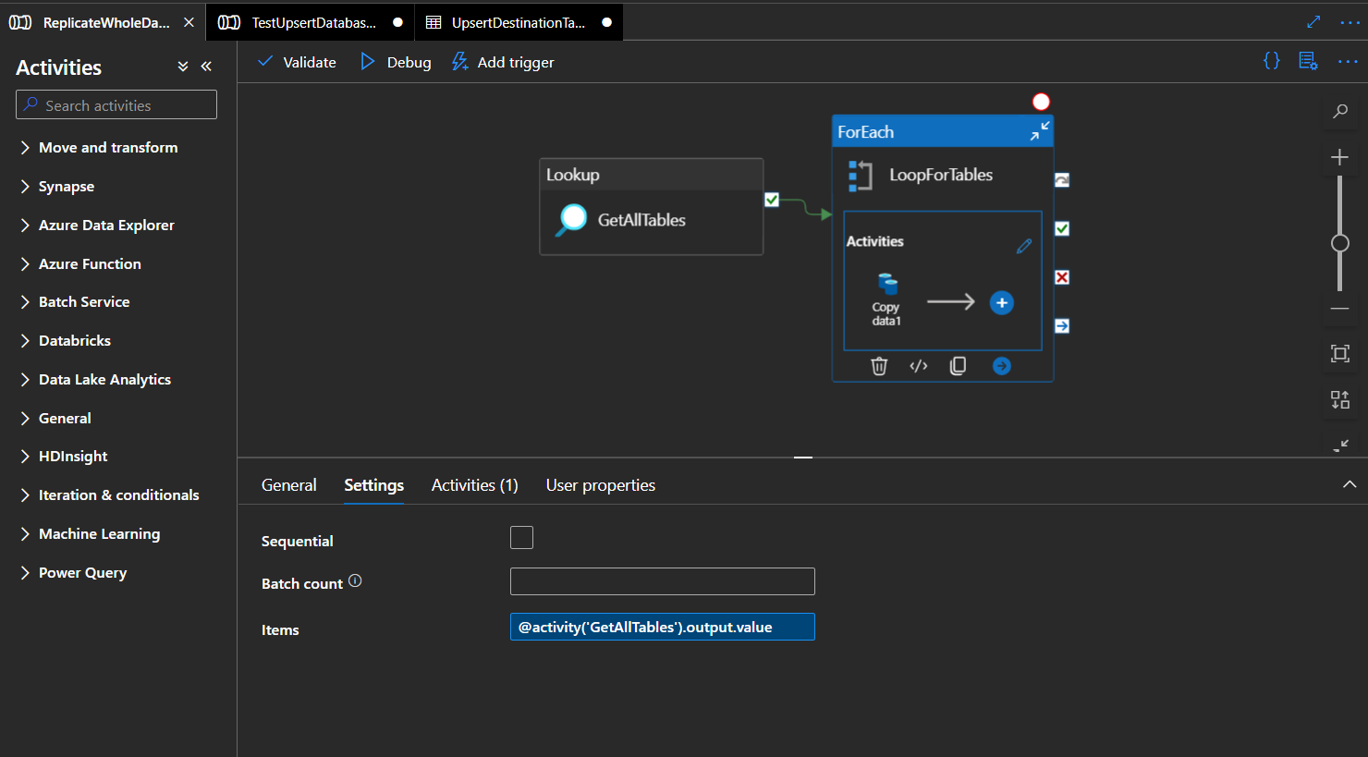
  - Select edit on the “Foreach”.
    - @activity('GetAllTables').output.value (Setting)
  - Select your source and add parameters to it. Your source can then use the parameters to copy the table names.
    - Click on the open SQL Server and add parameters, it will display like this.
    - 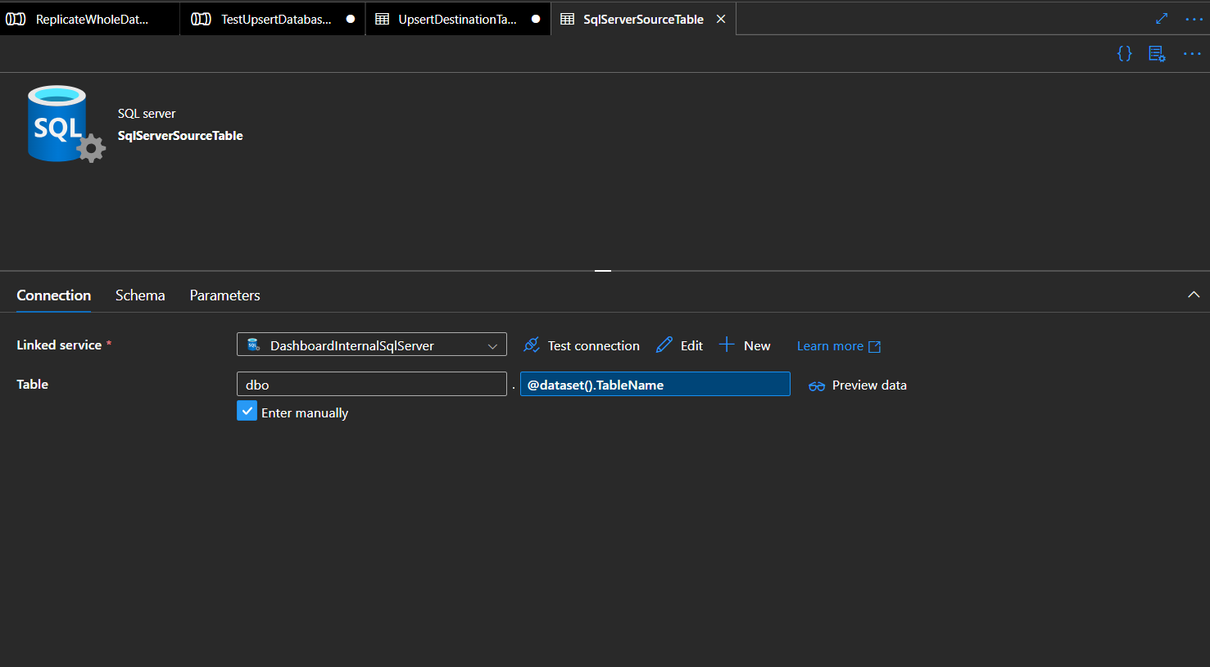
    - 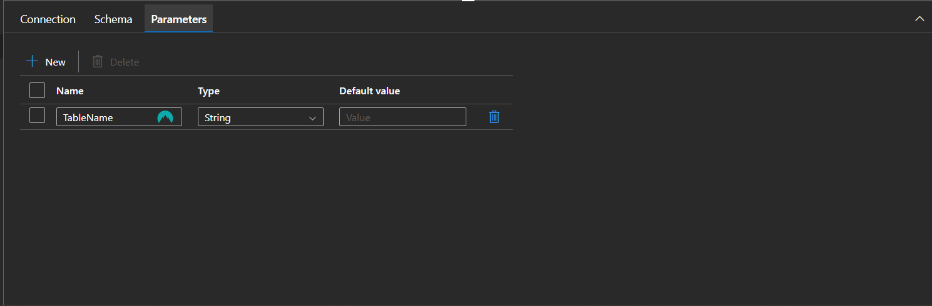
  - Go to Sink and select your destination source, repeat the same process but use “DestinationTable” instead of “TableName”.
    - 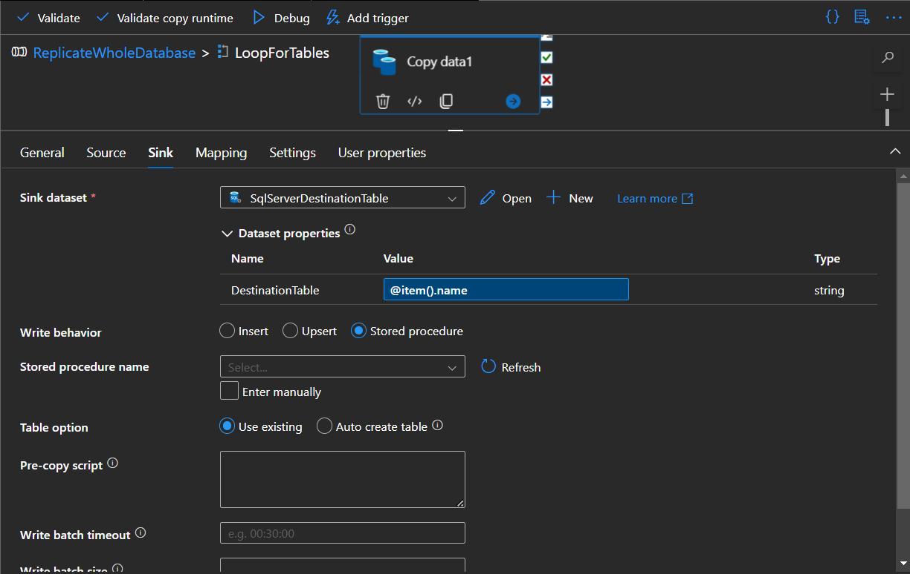
    - Also, tick the auto Create table instead of using the existing one.
    - Use stored procedures instead of upsert and insert because they need mapping and key columns to map the schema.
  - Use Validation before hitting the debug as it will validate your database.
    - 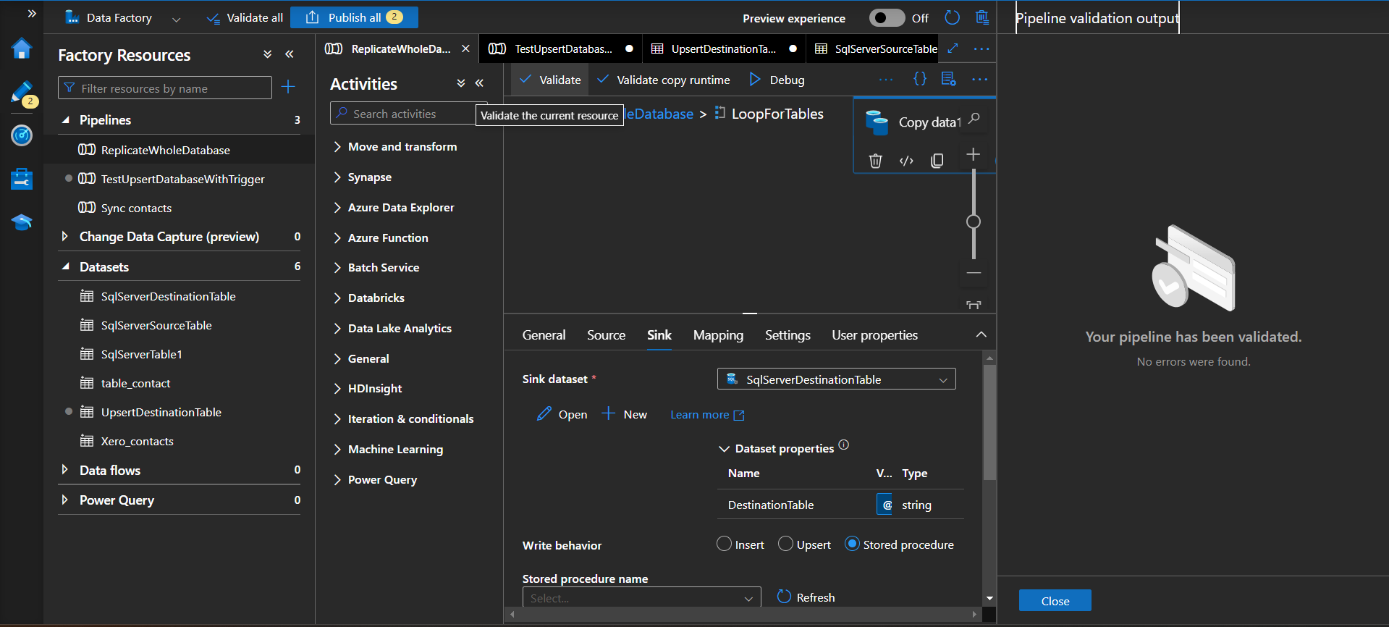
    - After validating, hit on debug and check the process and after a few minutes it will be successful.
  - In the end, publish it.

Reference-
  - Bulk store data for the database.

Limitations-
- Use of triggers will insert duplicates for existing tables.
  - Remove the schema from the “SQL Server” and debug the Pipeline.
  - Create another pipeline to remove complexity and use the array method.

Overcome-
- I have created a new pipeline with the reference of the above link which will truncate the original schema and table name, then store the data.
- Monitor the pipeline after implementing the trigger and check for duplicate data.

Get Table List And Trigger Copy Data

Interface
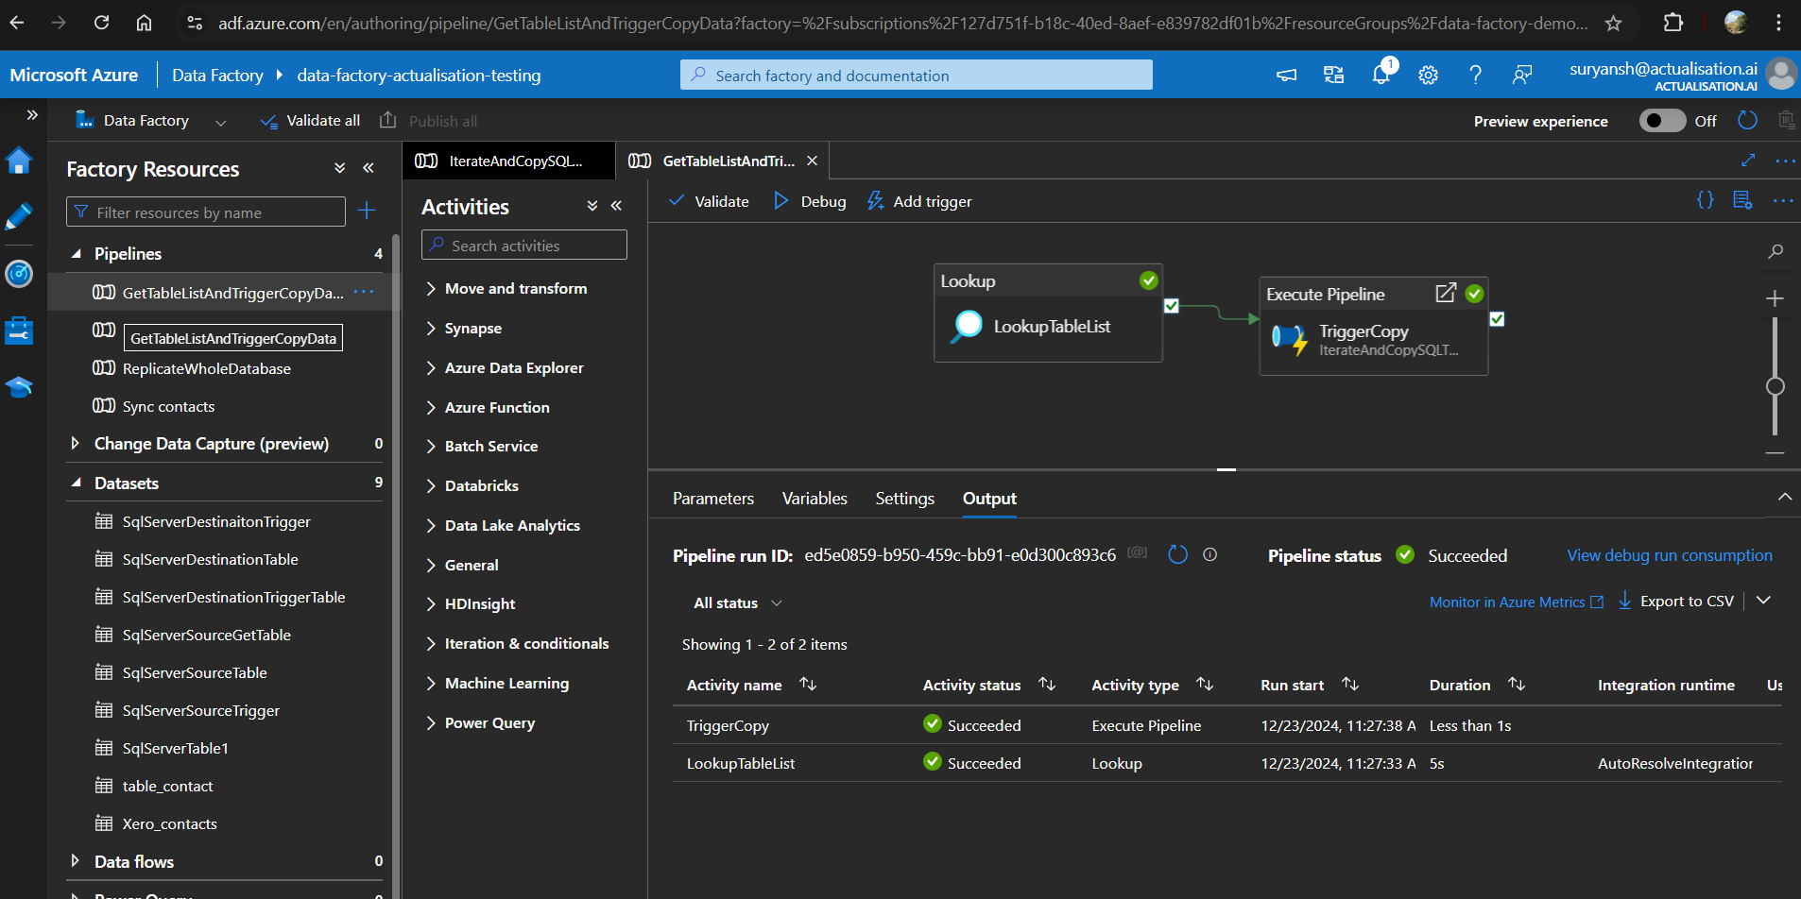

How to use it?
- Go to the pipeline and hit the validate option to make sure the pipeline is validated properly.
- After validating your screen will pop with this output.
  - 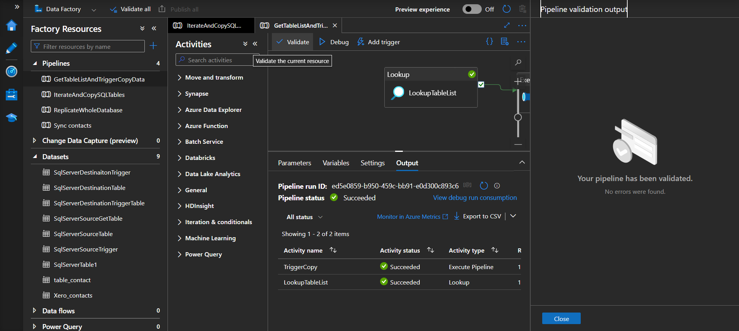
- To manually trigger it, hit on the debug and it will get manually triggered.
- Added trigger function.
  - 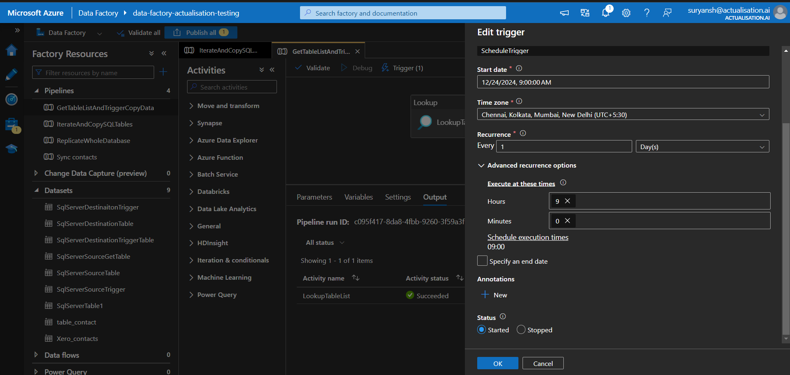
  - Every morning it will get triggered automatically and there’s no end date.
  - We can also specify the dates and weeks.
  - We can specify the Time zone also.
- 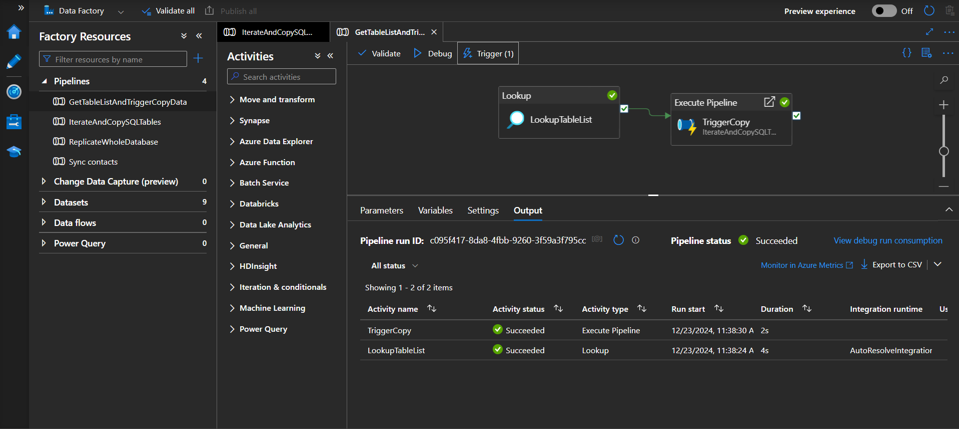
  - Final pipeline.
- Query specified pipeline.
- You can monitor the error and success of the pipeline
  - 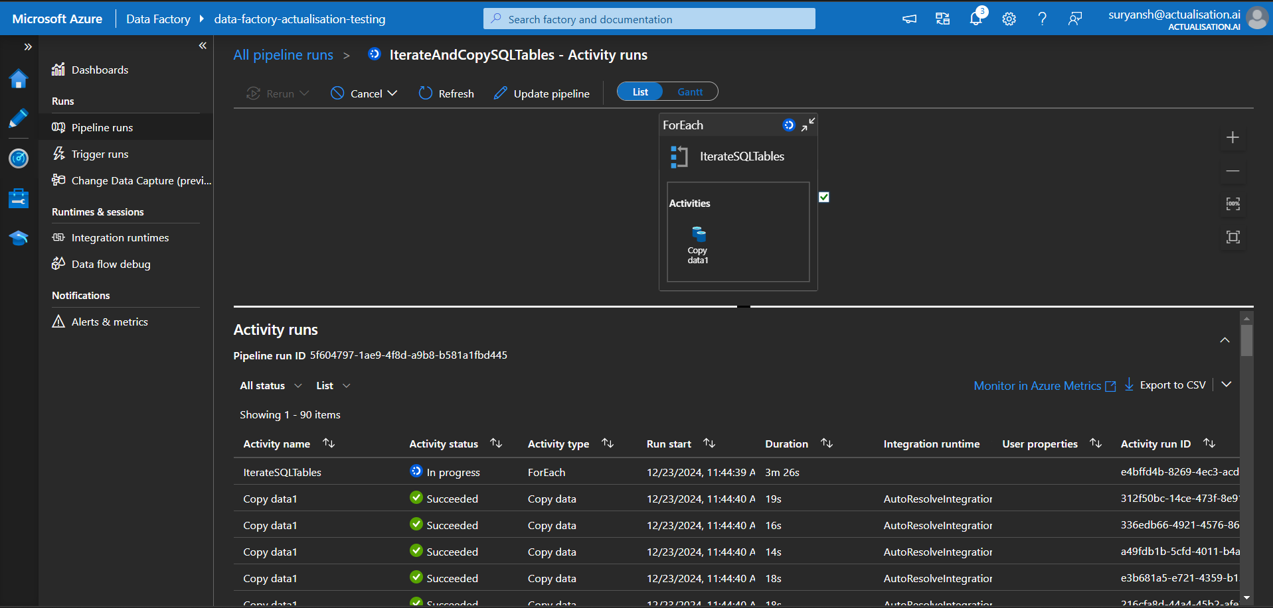
  - You can check if you have any problem with this icon.
  - 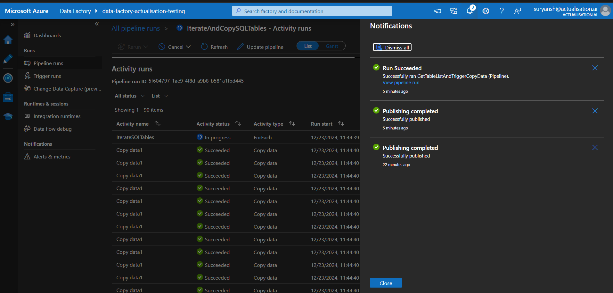
- The time to update the database will increase.
- If you want to add new tables we have to run the previous pipeline so it can update the schema.
- This pipeline only performs truncate and then performs insertion.
- It will not update the schema.
- Queries →
Query for Lookup | WITH RECURSIVE_CTE AS ( -- Anchor member: Find root tables SELECT OBJECT_ID(QUOTENAME(SCHEMA_NAME(t.schema_id)) + '.' + QUOTENAME(t.name)) AS TableID, t.name AS TableName, SCHEMA_NAME(t.schema_id) AS SchemaName, 0 AS Level FROM sys.tables t WHERE NOT EXISTS ( SELECT 1 FROM sys.foreign_keys fk WHERE fk.referenced_object_id = t.object_id ) UNION ALL -- Recursive member: Follow foreign key references SELECT OBJECT_ID(QUOTENAME(SCHEMA_NAME(t.schema_id)) + '.' + QUOTENAME(t.name)), t.name, SCHEMA_NAME(t.schema_id), r.Level + 1 FROM sys.tables t INNER JOIN sys.foreign_keys fk ON fk.parent_object_id = t.object_id INNER JOIN RECURSIVE_CTE r ON fk.referenced_object_id = r.TableID ), ALL_TABLES AS ( SELECT SCHEMA_NAME(t.schema_id) AS SchemaName, t.name AS TableName, OBJECT_ID(QUOTENAME(SCHEMA_NAME(t.schema_id)) + '.' + QUOTENAME(t.name)) AS TableID FROM sys.tables t ), FINAL_RESULT AS ( SELECT c.SchemaName, c.TableName, MAX(c.Level) AS DependencyLevel FROM RECURSIVE_CTE c GROUP BY c.SchemaName, c.TableName UNION ALL SELECT a.SchemaName, a.TableName, 0 AS DependencyLevel FROM ALL_TABLES a WHERE NOT EXISTS ( SELECT 1 FROM RECURSIVE_CTE r WHERE r.TableID = a.TableID ) ) SELECT SchemaName AS TABLE_SCHEMA, TableName AS TABLE_NAME, DependencyLevel AS LoadOrder FROM FINAL_RESULT
Pre-Script to handle Primary key While Time Trigger | -- Generic Duplicate Deletion Pre-Copy Script (Handles existing rows) DECLARE @TableSchema NVARCHAR(128) = '@{item().TABLE_SCHEMA }'; DECLARE @TableName NVARCHAR(128) = '@{item().TABLE_NAME }'; DECLARE @PrimaryKeyColumns NVARCHAR(MAX) = ''; DECLARE @WhereClause NVARCHAR(MAX) = ''; DECLARE @DeleteSQL NVARCHAR(MAX) = ''; -- Get primary keys SELECT @PrimaryKeyColumns += CASE WHEN LEN(@PrimaryKeyColumns) = 0 THEN QUOTENAME(COLUMN_NAME) ELSE ', ' + QUOTENAME(COLUMN_NAME) END FROM INFORMATION_SCHEMA.KEY_COLUMN_USAGE WHERE OBJECTPROPERTY(OBJECT_ID(CONSTRAINT_NAME), 'IsPrimaryKey') = 1 AND TABLE_SCHEMA = @TableSchema AND TABLE_NAME = @TableName; -- Build WHERE clause to match primary keys (for deletion) SELECT @WhereClause += CASE WHEN LEN(@WhereClause) = 0 THEN 't.' + QUOTENAME(COLUMN_NAME) + ' = s.' + QUOTENAME(COLUMN_NAME) ELSE ' AND t.' + QUOTENAME(COLUMN_NAME) + ' = s.' + QUOTENAME(COLUMN_NAME) END FROM INFORMATION_SCHEMA.KEY_COLUMN_USAGE WHERE OBJECTPROPERTY(OBJECT_ID(CONSTRAINT_NAME), 'IsPrimaryKey') = 1 AND TABLE_SCHEMA = @TableSchema AND TABLE_NAME = @TableName; -- Delete matching rows in sink table SET @DeleteSQL = ' DELETE t FROM [' + @TableSchema + ' ].[' + @TableName + ' ] t JOIN (SELECT ' + @PrimaryKeyColumns + ' FROM [' + @TableSchema + ' ].[' + @TableName + ' ]) s ON ' + @WhereClause; -- Execute the delete BEGIN TRY EXEC sp_executesql @DeleteSQL; PRINT 'Existing rows deleted from [' + @TableSchema + ' ].[' + @TableName + ' ]'; END TRY BEGIN CATCH PRINT 'ERROR in DELETE: ' + ERROR_MESSAGE(); END CATCH;

